Service Now Project Documentation

Introduction

- Project Title: Educational Organisation Using ServiceNow
- Team Members:
- Kavya Sree Manchinti
- Yadadhala Kalyan Reddy
- Navarasala Lakshmi Prasanna
- M Madhavi

Project Overview

- Purpose: To develop a robust Educational Management System using ServiceNow to manage admissions, student progress, and institutional data with automated workflows and form configurations.
- Features:
- Online admission form with approval workflow
- Student and teacher data management
- Academic progress tracking dashboard
- Notifications for task status and approvals
- Role-based access control for admins, teachers, and students

Architecture

- Frontend:
  - Developed using HTML, CSS, and JavaScript
  - UI built through ServiceNow UI Pages and Catalog Items
- Backend:
  - Business logic implemented via ServiceNow Script Includes, Business Rules, and Flow Designer
- Database:
  - Tables created using the Table module in ServiceNow
  - Data stored in platform-native schema with relationships and references

Setup Instructions

- Prerequisites:
o ServiceNow Developer Account
o Personal Developer Instance (PDI)
o Basic knowledge of ServiceNow Studio
- Installation Steps:
Step 1: Sign in at https://developer.servicenow.com
Step 2: Request and activate your Personal Developer Instance
Step 3: Create Update Set → Tables → Forms → Process Flows
Step 4: Deploy Client Scripts for automation

Folder Structure (Logical in Studio)

EducationalOrganisation/
├── Tables/
│ ├── x_edu_student
│ ├── x_edu_teacher
│ ├── x_edu_admission
│ └── x_edu_progress
├── UI Pages/
│ ├── admission_form
│ └── student_dashboard
├── Script Includes/
│ └── AdmissionWorkflowUtils
├── Client Scripts/
│ └── validate_form.js
└── Styles/
└── styles.css

Running the Application

To run the application:
- Login to your ServiceNow PDI
- Navigate to the created application

- Use the left navigation pane to open modules such as:
o Admission Form
o Student Records
o Progress Dashboard
- Perform form submissions and automation testing

API Documentation
- GET /api/x_edu_org/students
- Response:
  - {
  - "student_id": "STU102",
  - "name": "A. Chaithanya",
  - "department": "Computer Science"
  - }

Authentication
• Role-based access is implemented using admin, teacher, and student roles, managed through ServiceNow Access Control Rules (ACLs).

User Interface
- Designed with HTML, CSS, and JavaScript using ServiceNow UI Pages for a clean and responsive layout.
- Includes dashboards, admission forms, student profiles, and result tracking interfaces.
- Role-based access displays relevant modules for admin, teacher, and student users.

Testing
- Manual testing was done through the ServiceNow form submission interface.
- Validations verified via onChange and onLoad client scripts.
- Fields were tested for automation, data flow, and visual updates.

Screenshots or Demo
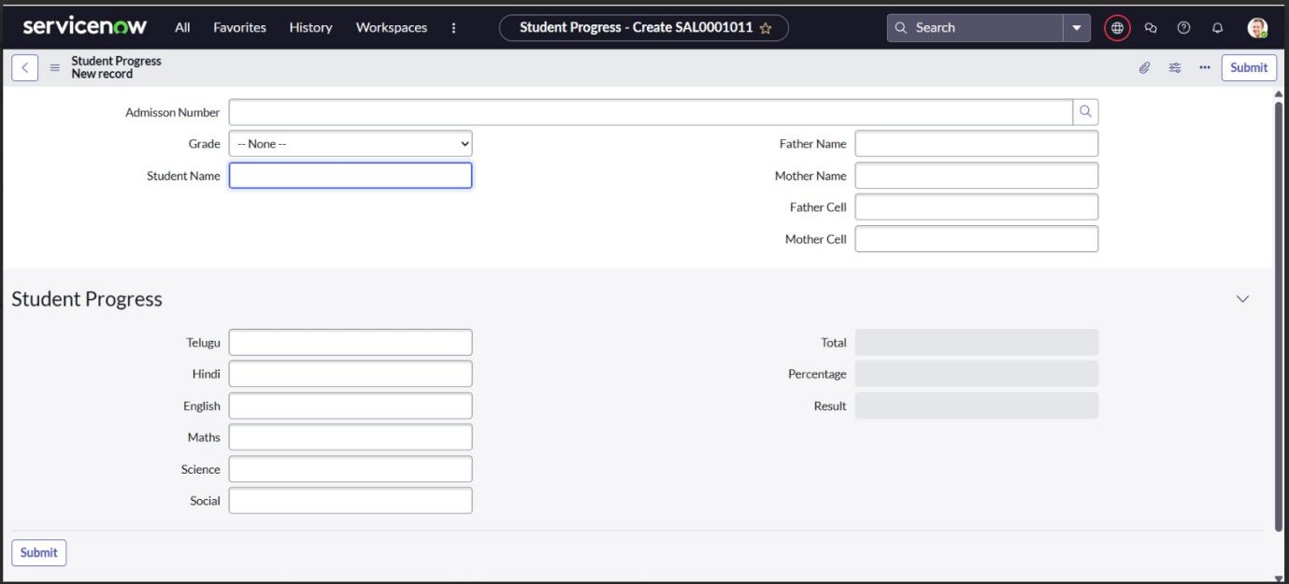

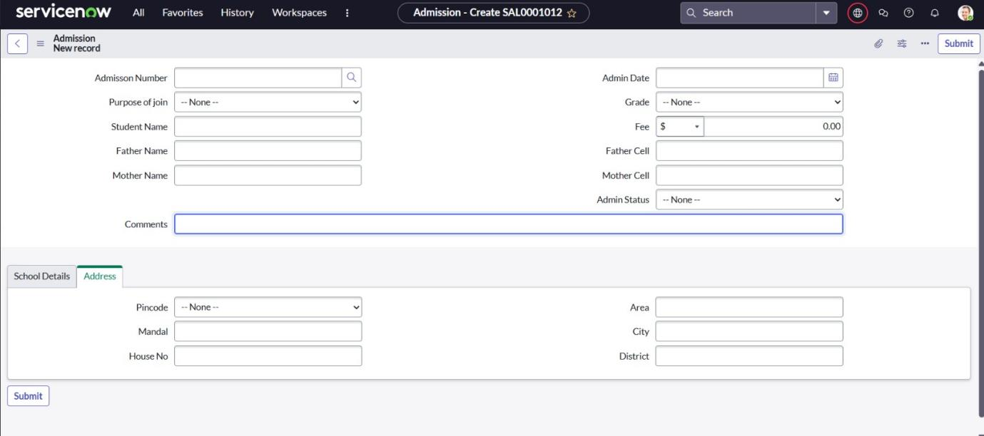

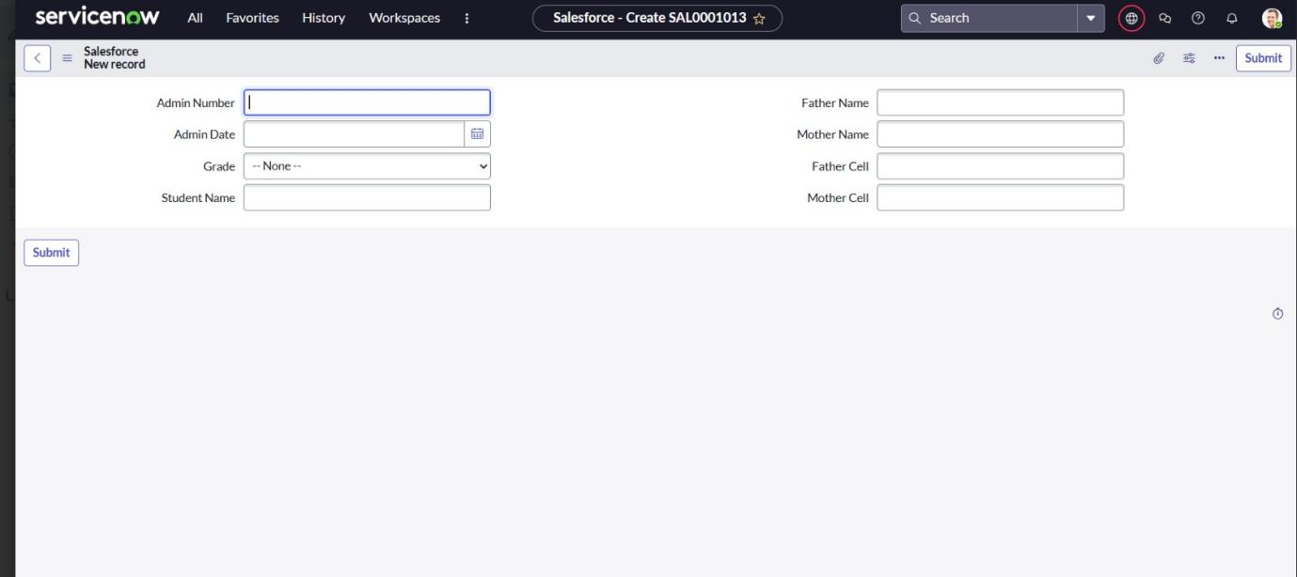

Known Issues
- Form layout may vary slightly on different devices.
- Client Scripts dependent on exact field naming — ensure accuracy.

Future Enhancements
- Add role-based user dashboards
- Integrate notifications (email/SMS) for admission status
- Extend to manage teacher data and fee structure
- Add reporting dashboards using ServiceNow Performance Analytics

